**PROJECT REPORT**

**UFO and Planets**

**MODULE: 3D PROGRAM**

| Author | Nguyễn Tuấn Dũng |
| --- | --- |
| Class | 20CSE |
| Supervisor | Mrs. Dang Thao |
| Supervisor | VN-UK Institute for Research and Executive Education |

**UFO and Planets**

Before we began, I would like to thank my institute Mrs. Dang Thao, whose stimulating suggestions and encouragement aided us in coordinating our project, particularly in the writing of this report.

**1 introduction 3**

**2.** **UFO and Planets 4**

1.1 Application Overview 4

1.2 Coding Structure 4

1.3 Experience Instructions 4

1.4 Demonstration Results 4

**3**. **CONCLUSION 6**

# 1 introduction

In terms of academic and non-academic perspectives, the project report highlights my major works. This document aims to identify and describe the analysis performed, tasks completed, and experience gained while concentrating on the accomplishments made during the implementation of this product.

I found myself rather lucky by getting the chance to work on such a challenging project. “UFO and Planets” is developed using Javascript, Threejs, and HTML programming language. I attempted to create a fully completed product, including coding features and a user interface, to create a project reflecting the teaching materials in the 3D Programming learning module.

This report is under the provision of Mrs. Dang Thao, lecturer at The University of Danang, VN-UK Institute for Research and Executive Education.

# 2. UFO and Planets

## Project Overview

UFO and Planets is a project written in JavaScript in conjunction with Threejs and HTML. UFO and Planets create an environment where players can listen to music and play around with the UFO.

This product would attempt to practice and implement 3D Programming knowledge, which is the purpose of the 3D Programming module at VN-UK Institute for Research and Executive Education. Therefore, this final product is initially created for internal use only, which means to be used merely for the learning environment within the institute and would never be in public for any commercial purposes.

## Coding Structure

The following figure indicates the structure of the whole source structure of “UFO and Planets”. There are several main files:

* *index.html: This is the application's main source file and where the audio is handled.*
* *main.js: This is the file responsible for handling events from clients and managing environment, objects, and gameplay.*
* *three.js: Set up the environment to use threejs in coding.*
* *README.md: Describe the project.*

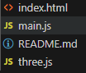

UFO and Planets Viewer Source Code Structure

The entire source code can be seen via this git: <https://github.com/DungNT0/3D_Final_Project.git>

## Experience Instructions

UFO and Planets can be deployed by running “npx serve” in VScode terminal.

UFO, audio, and camera controls are in the readme file.

## Demonstration Results

After a sincere effort in an investigation to implement the product, I have released UFO and Planets version 1.0 which has several planets, a UFO, audio, a button that mutes and plays audio. skybox, keyboard, and camera interaction.

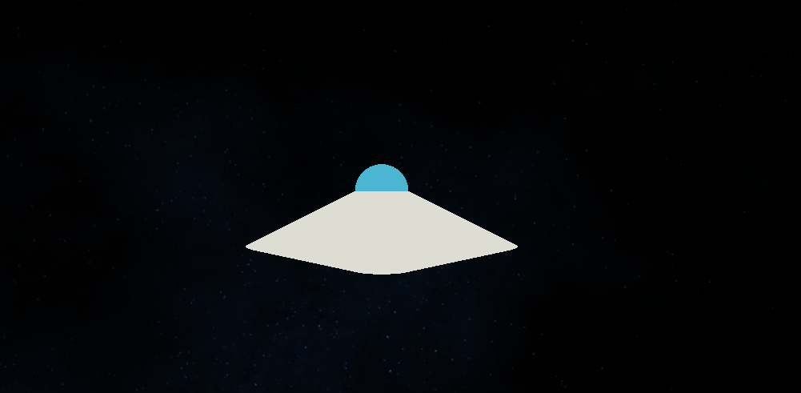

UFO and Planets run

# 3. CONCLUSION

Throughout the implementation process of UFO and Planets, this project has helped me gain important knowledge in how to create 3D from WebGL, use ThreeJs library, and program a fully completed product from the initial phase to the final release.

Finally, I would like to convey our thanks to Mrs. Dang Thao and The University of Danang VN-UK Institute for Research and Executive Education for providing the class with a challenge, as well as an opportunity, to gain an idea for creating a completed application. It has certainly lifted our skills in design and coding. We now look forward to continuing our career plan and facing the upcoming challenges of the world.

*NVScene.* [*"NVScene 2015 Session: Reinventing The Wheel - One Last Time (Ricardo Cabello)"*](https://www.youtube.com/watch?v=LXWYOF4VibE)*. YouTube.*

1. [*"Three.js White Paper"*](https://github.com/mrdoob/three.js/issues/1960)*. Github.com. 2012-05-21. Retrieved 2013-05-09.*
2. *Mr.doob (2020-08-03),* [*mrdoob/three.js*](https://github.com/mrdoob/three.js)*, retrieved 2020-08-03*
3. *mrdoob (2012-11-26).* [*"Features mrdoob/three.js Wiki GitHub"*](https://github.com/mrdoob/three.js/wiki/Features)*. Github.com. Retrieved 2013-05-09.*
4. [*"Stats.js"*](https://github.com/mrdoob/stats.js)*. Github.com. Retrieved 2013-05-09.*
5. [*"WebGL Inspector"*](https://benvanik.github.com/WebGL-Inspector/)*. Benvanik.github.com. Retrieved 2013-05-09.*
6. [*"Three.js Inspector Labs"*](https://zz85.github.com/zz85-bookmarklets/threelabs.html)*. Zz85.github.com. Retrieved 2013-05-09.*
7. ["three.js examples"](https://threejs.org/examples/?q=webxr). *threejs.org*.



